

# 

### Semester Two Examination, 2016

### Question/Answer Booklet

# MATHEMATICS

**SOLUTIONS**

**APPLICATIONS**

**UNITS 1 AND 2**

## Section One:

## Calculator-free

|  |  |  |  |  |  |  |  |  |
| --- | --- | --- | --- | --- | --- | --- | --- | --- |
| Student Number: In figures |  |  |  |  |  |  |  |  |

In words

Your name

## Time allowed for this section

Reading time before commencing work: five minutes

Working time for section: fifty minutes

## Materials required/recommended for this section

***To be provided by the supervisor***

This Question/Answer Booklet

Formula Sheet

***To be provided by the candidate***

Standard items: pens (blue/black preferred), pencils (including coloured), sharpener, correction fluid/tape, eraser, ruler, highlighters

Special items: nil

## Important note to candidates

No other items may be taken into the examination room. It is **your** responsibility to ensure that you do not have any unauthorised notes or other items of a non-personal nature in the examination room. If you have any unauthorised material with you, hand it to the supervisor **before** reading any further.

## Structure of this paper

|  |  |  |  |  |  |
| --- | --- | --- | --- | --- | --- |
| Section | Number of questions available | Number of questions to be answered | Working  time (minutes) | Marks available | Percentage of exam |
| Section One:  Calculator-free | 7 | 7 | 50 | 51 | 35 |
| Section Two:  Calculator-assumed | 13 | 13 | 100 | 99 | 65 |
|  | | | **Total** | 150 | 100 |

## Instructions to candidates

1. The rules for the conduct of examinations are detailed in the school handbook. Sitting this examination implies that you agree to abide by these rules.

2. Write your answers in this Question/Answer Booklet.

3. You must be careful to confine your response to the specific question asked and to follow any instructions that are specified to a particular question.

4. Spare pages are included at the end of this booklet. They can be used for planning your responses and/or as additional space if required to continue an answer.

* Planning: If you use the spare pages for planning, indicate this clearly at the top of the page.
* Continuing an answer: If you need to use the space to continue an answer, indicate in the original answer space where the answer is continued, i.e. give the page number. Fill in the number of the question that you are continuing to answer at the top of the page.

5. **Show** **all your working clearly**. Your working should be in sufficient detail to allow your answers to be checked readily and for marks to be awarded for reasoning. Incorrect answers given without supporting reasoning cannot be allocated any marks. For any question or part question worth more than two marks, valid working or justification is required to receive full marks. If you repeat any question, ensure that you cancel the answer you do not wish to have marked.

6. It is recommended that you **do not use pencil**, except in diagrams.

7. The Formula Sheet is **not** to be handed in with your Question/Booklet.

Section One: Calculator-free 35% (51 Marks)

This section has**seven (****7)** questions. Answer **all** questions. Write your answers in the spaces provided.

Working time for this section is 50 minutes.

Question 1 (6 marks)

(a) If $a=10$, $t=2$ and $u=5.5$, determine the value of $s$, where $s=ut+\frac{1}{2}at^{2}$. (2 marks)

|  |
| --- |
| **Solution** |
| $$s=5.5×2+\frac{1}{2}×10×2^{2} \\ =11+20=31$$ |
| **Specific behaviours** |
| ✓ substitutes correctly  ✓ evaluates |

(b) If $m=\frac{a+b+c}{3}$, determine the value of $a$ when $b=10$, $c=13$ and $m=9$. (2 marks)

|  |
| --- |
| **Solution** |
| $$9=\frac{a+10+13}{3} \\ 27=a+23⇒a=4$$ |
| **Specific behaviours** |
| ✓ substitutes correctly  ✓ evaluates |

(c) If $d=\sqrt{b^{2}-4ac}$, determine the value of $a$ when $b=3$, $c=-1$ and $d=5$. (2 marks)

|  |
| --- |
| **Solution** |
| $$5=\sqrt{3^{2}-4\left(a\right)\left(-1\right)} \\ 25=9+4a⇒4a=16⇒a=4$$ |
| **Specific behaviours** |
| ✓ substitutes and squares both sides  ✓ solves for $a$ |

Question 2 (7 marks)

A group of 28 people gave a movie they had just watched together a rating of between one and five stars. Their star ratings are listed below:

|  |  |  |  |  |  |  |  |  |  |  |  |  |  |
| --- | --- | --- | --- | --- | --- | --- | --- | --- | --- | --- | --- | --- | --- |
| 2 | 4 | 4 | 2 | 2 | 1 | 4 | 4 | 4 | 2 | 4 | 3 | 3 | 1 |
| 5 | 2 | 4 | 5 | 2 | 4 | 4 | 2 | 2 | 3 | 2 | 5 | 4 | 3 |

(a) Explain why this type of data is considered categorical and choose **one** more word to further describe the data from the following list: nominal, ordinal, discrete, continuous.

(2 marks)

|  |
| --- |
| **Solution** |
| Categorical **ordinal**. A star rating is not a measurement but simply a way of categorising a person's opinion of a movie. |
| **Specific behaviours** |
| ✓ explains categorical.  ✓ chooses correct descriptor |

(b) Complete the frequency table below for the ratings. (2 marks)

|  |
| --- |
| **Solution** |
| See table |
| **Specific behaviours** |
| ✓ frequencies add to 28  ✓ all frequencies correct |

|  |  |  |
| --- | --- | --- |
| Rating | Tally | Frequency |
| 1 |  | 2 |
| 2 |  | 9 |
| 3 |  | 4 |
| 4 |  | 10 |
| 5 |  | 3 |

(c) Display the ratings as bar graph using the grid below. (3 marks)

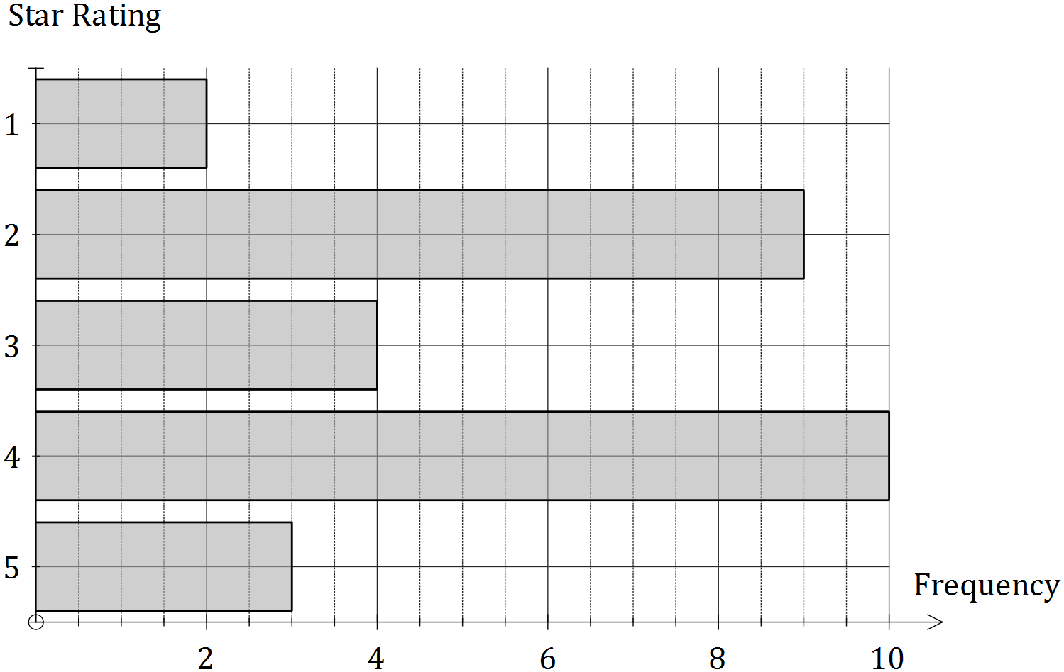

|  |
| --- |
| **Solution** |
| See graph |
| **Specific behaviours** |
| ✓ scale and 'f' on frequency axis, labels and description on category axis  ✓ bars are equal width and parallel  ✓ length of bars matches frequency table |

Question 3 (7 marks)

Consider the matrices $A=\left[\begin{matrix}2 & 1 \\ -1 & 3\end{matrix}\right]$, $B=\left[\begin{matrix}5 \\ -3\end{matrix}\right]$, $C=\left[\begin{matrix}3 & -2 \\ 1 & 0\end{matrix}\right]$ and $D=[\begin{matrix}6 & 2\end{matrix}]$.

(a) Calculate, where possible, the following. If not possible, explain why.

(i) $5C$. (1 mark)

|  |
| --- |
| **Solutions** |
| $5C=\left[\begin{matrix}15 & -10 \\ 5 & 0\end{matrix}\right]$ $2D+3B$: Not possible as not same size $A-C=\left[\begin{matrix}-1 & 3 \\ -2 & 3\end{matrix}\right]$ $AC=\left[\begin{matrix}7 & -4 \\ 0 & 2\end{matrix}\right]$ |
| **Specific behaviours** |
| (i) - (iii) ✓ each for correct answer  (iv) ✓ correct column or row; ✓ all correct |

(ii) $2D+3B$. (1 mark)

(iii) $A-C$. (1 mark)

(iv) $AC$. (2 marks)

(b) Determine the value of $x$ if $\left[\begin{matrix}2 & -2 & x\end{matrix}\right]×\left[\begin{matrix}x \\ 4 \\ 3\end{matrix}\right]=[4x]$. (2 marks)

|  |
| --- |
| **Solution** |
| $2x-8+3x=4x⇒5x-8=4x⇒x=8$ |
| **Specific behaviours** |
| ✓ multiplies matrices  ✓ solves equation for $x$ |

Question 4 (9 marks)

The graph below, developed by Monsieur Le Beau, can be used to determine if a cat is old or young in relation to human age. For example, a one-year-old cat ($c=1$) will have the equivalent age of a fifteen-year-old human ($h=15$).

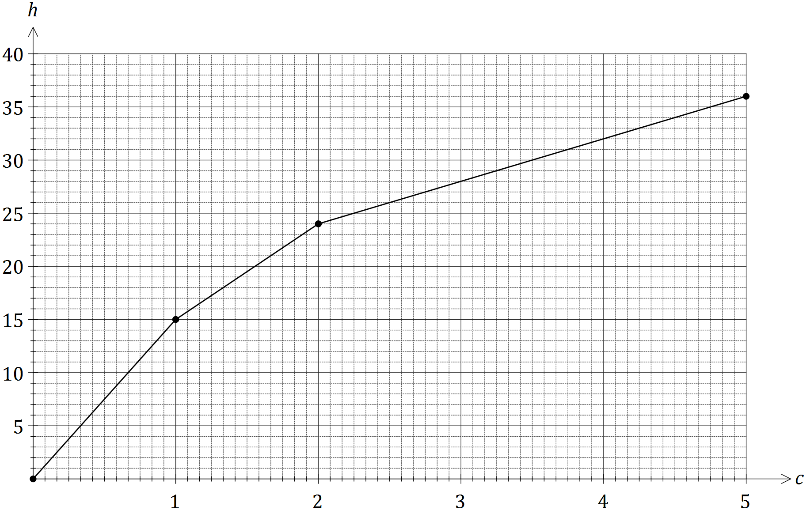

(a) Use the graph to determine

(i) the equivalent human age of a cat that is four and a half years old. (1 mark)

|  |
| --- |
| **Solution** |
| 34 years old |
| **Specific behaviours** |
| ✓ states value |

(ii) the age of a cat with an equivalent human age of 18 years. (1 mark)

|  |
| --- |
| **Solution** |
| 1 year and 4 months |
| **Specific behaviours** |
| ✓ states value |

(b) Calculate the gradient of the line for cats that are between one and two years old, and interpret what its value means in this context. (2 marks)

|  |
| --- |
| **Solution** |
| $m=\frac{24-15}{2-1}=9$ Cat is ageing at a rate of 9 human years per cat year |
| **Specific behaviours** |
| ✓ calculates gradient  ✓ interprets in context |

(c) Determine the equation of the line for cats that are two years or older. (3 marks)

|  |
| --- |
| **Solution** |
| $m=\frac{36-24}{5-2}=\frac{12}{3}=4$ $h=4c+k⇒24=4\left(2\right)+k⇒k=16$ $h=4c+16$ |
| **Specific behaviours** |
| ✓ determines gradient  ✓ determines axes-intercept  ✓ writes equation using correct variables |

(d) Use your equation from (c) to determine the age of a cat with an equivalent human age of 60 years. (2 marks)

|  |
| --- |
| **Solution** |
| $60=4c+16$ $4c=44$ $c=11$- cat is 11 years old |
| **Specific behaviours** |
| ✓ substitutes into equation  ✓ solves equation |

Question 5 (9 marks)

The distributions of the percentage exam scores of a group of 39 students in Section One and Section Two of their Mathematics exam are shown below.

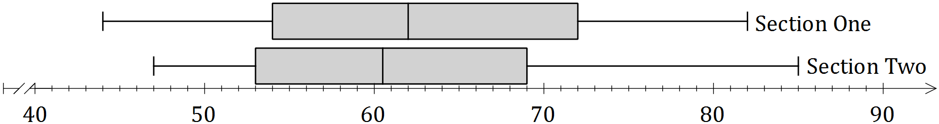

(a) Discuss, with reasoning based on statistics from the above distributions, in which section the students achieved better marks. (3 marks)

|  |
| --- |
| **Solution** |
| Overall, the students did better in Section One, as this section has the highest median ($62>60.5)$.  The upper and lower quartiles for Section One were also higher than for Section 2, despite the highest mark of 85 being obtained in Section Two and the lowest mark of 44 coming from a student in Section One. |
| **Specific behaviours** |
| ✓ chooses Section One  ✓ states and compares medians  ✓ notes Q1 and Q3 both higher for Section One, but not Min and Max |

(b) Discuss, with reasoning based on statistics from the above distributions, in which section the students' performance was more consistent. (3 marks)

|  |
| --- |
| **Solution** |
| More consistent in Section Two, since Section Two has the lowest IQR of 16 compared to 18 in Section One, despite both sets having the same range of 38. |
| **Specific behaviours** |
| ✓ chooses Section Two  ✓ states and compares IQRs  ✓ notes both ranges are 38 |

(c) A teacher suspected that the data set for one section may contain an outlier.

(i) State which data set and a brief reason for their suspicion. (1 mark)

|  |
| --- |
| **Solution** |
| Section Two - large right whisker |
| **Specific behaviours** |
| ✓ states set with reason |

(ii) Use a calculation to determine whether the data set identified above contains an outlier. (2 marks)

|  |
| --- |
| **Solution** |
| $Q_{3}+1.5×IQR=69+1.5×16=93$ Hence max score of 85 is not an outlier, as $85≤93$. |
| **Specific behaviours** |
| ✓ calculates Q3+1.5IQR  ✓ uses calculation to reason 85 not an outlier |

Question 6 (6 marks)

The table below shows the number of overseas (O) and local (L) letters sent by a company over a period of five consecutive days.

|  |  |  |  |  |  |  |  |  |  |
| --- | --- | --- | --- | --- | --- | --- | --- | --- | --- |
| *Mon* | | *Tue* | | *Wed* | | *Thu* | | *Fri* | |
| O | L | O | L | O | L | O | L | O | L |
| 0 | 8 | 2 | 5 | 1 | 10 | 5 | 15 | 3 | 6 |

(a) Represent this information in a $2×5$ matrix $M$. (2 marks)

|  |
| --- |
| **Solution** |
| $M=\left[\begin{matrix}0 & 2 & 1 & 5 & 3 \\ 8 & 5 & 10 & 15 & 6\end{matrix}\right]$ |
| **Specific behaviours** |
| ✓ top row correct  ✓ bottom row correct |

(b) The cost of sending a local letter is $1 and an overseas letter is $3. Show this information in matrix $C$ that can be multiplied by matrix $M$ to create a meaningful result. (1 mark)

|  |
| --- |
| **Solution** |
| $C=[\begin{matrix}3 & 1\end{matrix}]$ |
| **Specific behaviours** |
| ✓ writes matrix |

(c) Calculate the product of the two matrices from (a) and (b) and explain what information this matrix shows. (2 marks)

|  |
| --- |
| **Solution** |
| $C×M=[\begin{matrix}8 & 11 & 13 & 30 & 15\end{matrix}]$ Product shows the total cost of sending both types of letter each day |
| **Specific behaviours** |
| ✓ correct product  ✓ explains result |

(d) Multiplying your answer to (c) by another matrix $T$ will result in a $1×1$ matrix that represents the total cost of sending the letters over the five-day period. Determine a suitable matrix $T$. (1 mark)

|  |
| --- |
| **Solution** |
| $T=\left[\begin{matrix}1 \\ 1 \\ 1 \\ 1 \\ 1\end{matrix}\right]$ |
| **Specific behaviours** |
| ✓ writes matrix |

Question 7 (7 marks)

A prism, with a right-triangular cross-section and square base, has dimensions as shown in the diagram below.

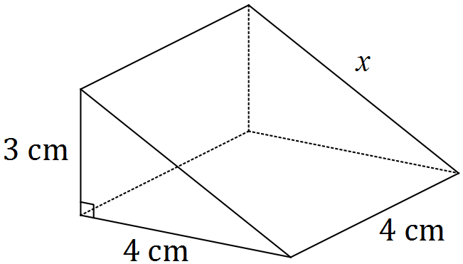

(a) Use Pythagoras' Theorem to show that the sloping edge marked $x$ is 5 cm long. (1 mark)

|  |
| --- |
| **Solution** |
| ${x^{2}=3}^{2}+4^{2}=9+16=25$ and so $x=5$ |
| **Specific behaviours** |
| ✓ shows use of theorem |

(b) Calculate the total surface area of the prism. (2 marks)

|  |
| --- |
| **Solution** |
| Two triangular ends:  TSA: cm2 |
| **Specific behaviours** |
| ✓ calculates area of triangles  ✓ calculates TSA |

(c) Calculate the volume of the prism. (1 mark)

|  |
| --- |
| **Solution** |
| cm3 |
| **Specific behaviours** |
| ✓ calculates volume |

(d) The prism is a $1:n$ scale model of a larger solid that has a square base measuring 28 cm by 28 cm.

(i) State the value of the scale factor $n$. (1 mark)

|  |
| --- |
| **Solution** |
| $n=28÷4=7$ |
| **Specific behaviours** |
| ✓ states value |

(ii) The total surface area of the larger solid can be determined by multiplying your answer to (b) by $k$. State the value of $k$. (1 mark)

|  |
| --- |
| **Solution** |
| $k=7^{2}=49$ |
| **Specific behaviours** |
| ✓ states value |

(ii) Write down a calculation that would give the volume of the larger solid, but do not evaluate it. (1 mark)

|  |
| --- |
| **Solution** |
| $V=7^{3}×24$ or $V=\frac{1}{2}×4×7×3×7×4×7$, etc |
| **Specific behaviours** |
| ✓ writes calculation |

Additional working space

Question number: _________

© 2016 WA Exam Papers. Narrogin Senior High School has a non-exclusive licence to copy and communicate this paper for non-commercial, educational use within the school. No other copying, communication or use is permitted without the express written permission of WA Exam Papers. SN131-83-0-0-2.